1)USE CASE DIAGRAM:

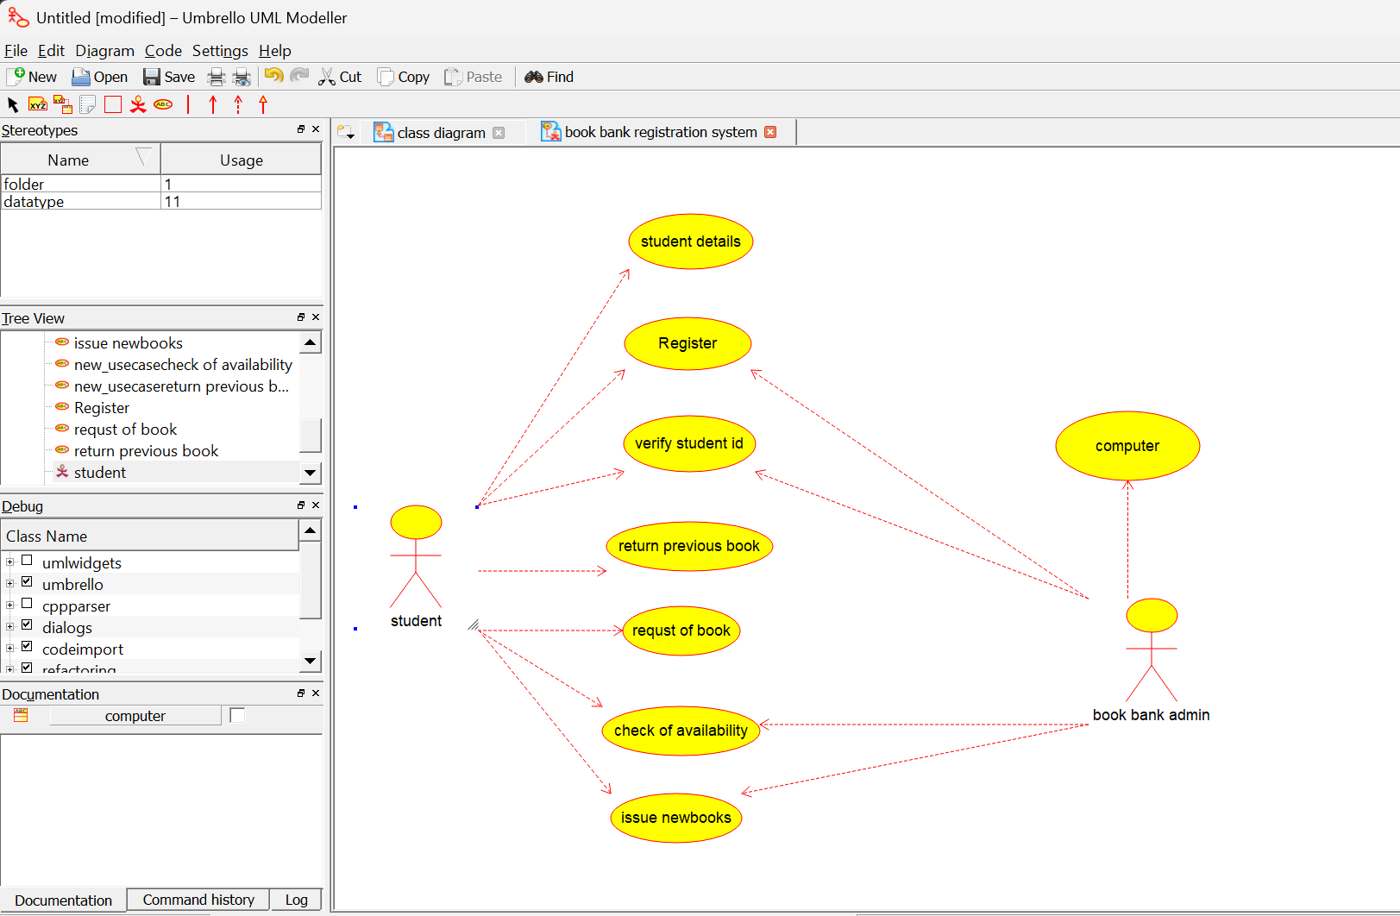

2)CLASS DIAGRAM

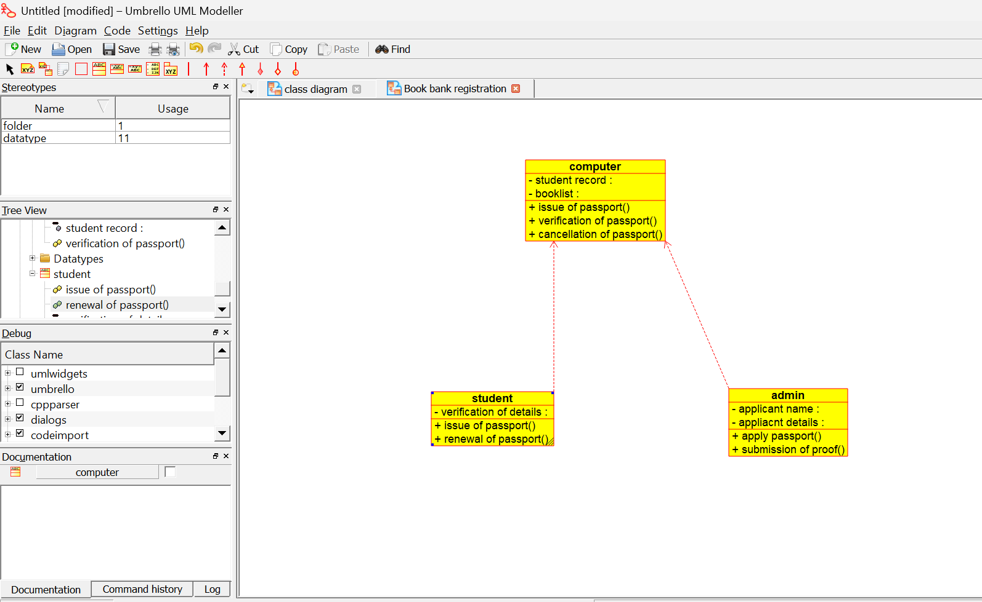

3)ACTIVITY DIAGRAM:

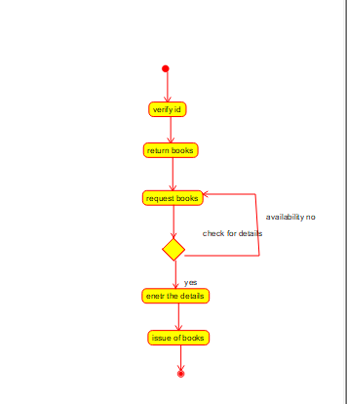

4)COMMUNICATION DIAGRAM:

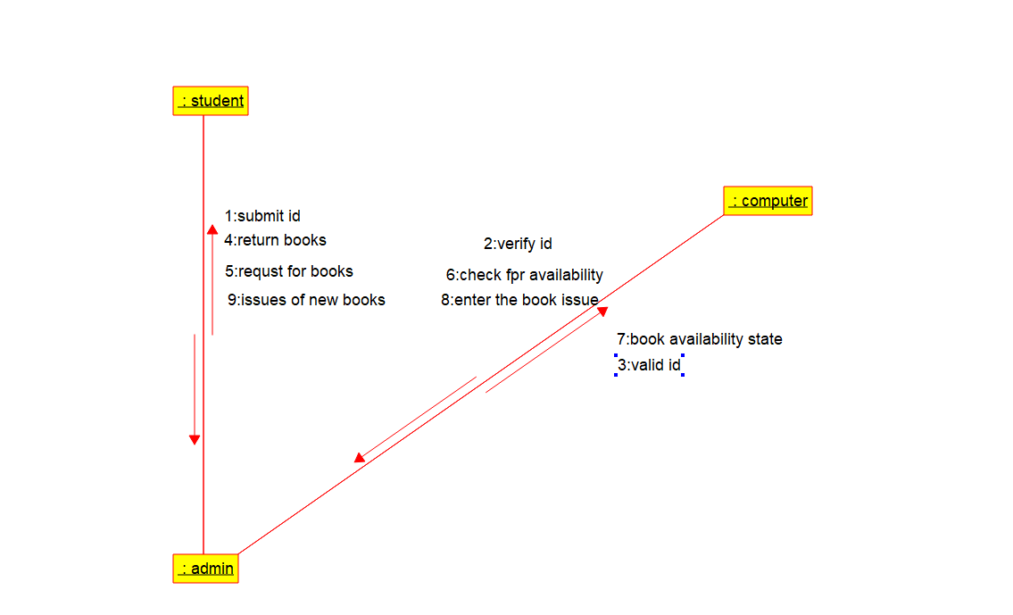

5)COMPONENT DIAGRAM:
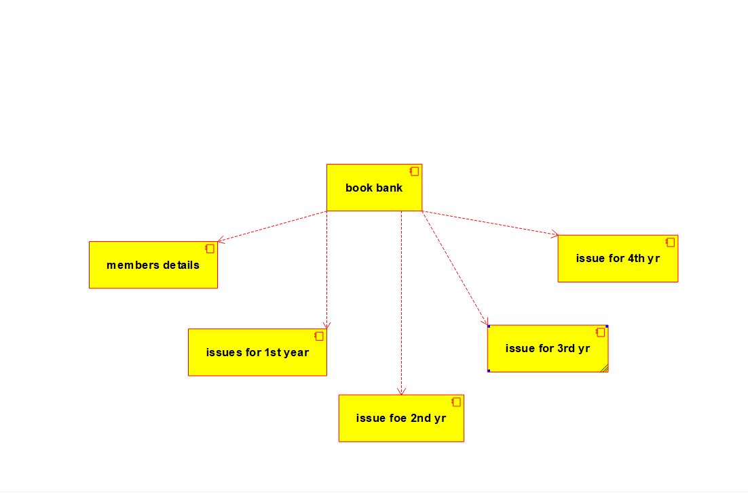

6)DEPLOYMENT DIGRAM:
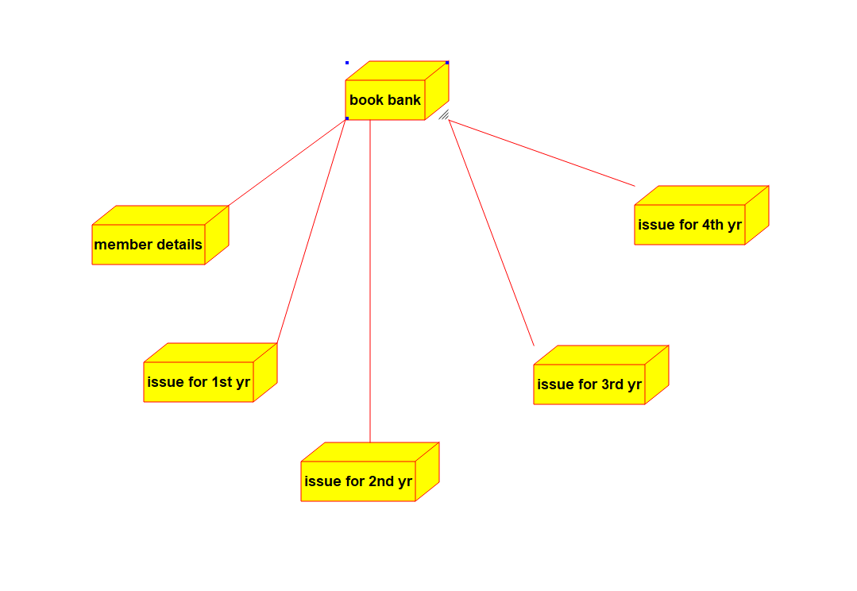

7)PACAKGE DIGRAM:

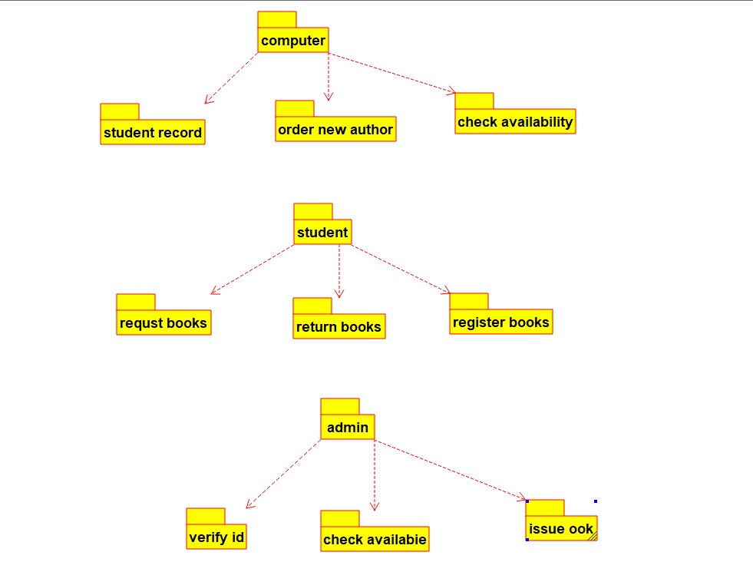

8)SEQUENCE DIAGRAM:
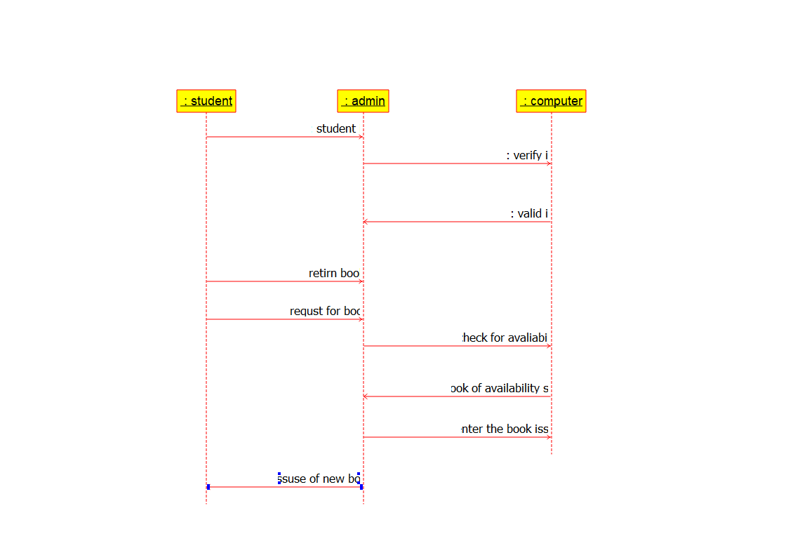
9)STATE DIGRAM:
